**Institute of Space Technology**

**Programming fundamentals LAB PROJECT**

**Submitted By: Abdullah Ahmad**

**Reg#200901057**

**Section: BSCS 01-B**

**Submitted To: Sir Asad Khan**

**Abstract;**

Hangman is a guessing game for two or more players. One player thinks of a word, phrase or sentence and the other(s) tries to guess it by suggesting letters within a certain number of guesses. Originally a Paper-and-pencil game, there are now electronic versions.

**Introduction:**

Hangman is a classic word guessing game for one or more players. One player thinks of a word, phrase or sentence and the other tries to guess it by suggesting letters or numbers. A typical hangman would require time and effort to design and implement. Due to the complexity of such a project, I aim to demonstrate a simplified version of the program. I will be using the C++ programming language to demonstrate the project in the command prompt. In this project the user will be ask to guess the month of the year, the user will answer this by entering a letter they think is in the word. The program will display a message when the user correctly or incorrectly guesses a letter and display all previously guessed letters so the user doesn't guess them again. The user have three (3) tries to incorrectly guess the word, whenever the user run out of tries the game will end otherwise if they get it correct they will be congratulated.

**Code:**

#include <iostream> #include <cstdlib> #include <ctime> #include <string> using namespace std;

double game;

//1. hangman Game start// int hangman ()

{

int letterFill (char, string, string&);

int tries=3; char letter;

int wrong_guesses=0; string word;

string words[] =

{"punjab", "balochistan", "sindh", "KPK", "NWFP"};

//select random word from array and replace all of it's characters with * srand(time(NULL));

int n=rand()% 5; word=words[n];

string unknown(word.length(),'*');

//game body that will show in output cout <<endl;

cout << "Hangman Game";

cout << "\n\nYou have " << tries << " tries to try and guess the word."<<endl;

// Loop until the guesses are used up while (wrong_guesses < tries)

{

cout << unknown;

cout << "\n\nGuess a letter: "; cin >> letter;

// Fill secret word with letter if the guess is correct, otherwise increment the number of wrong guesses.

if (letterFill(letter, word, unknown)==0)

{

cout << endl << "wrong guess" << endl; wrong_guesses++;

}

else

{

cout << endl << "letter found. Find other letters." << endl;

}

// Tell user how many guesses has left.

cout << "You have " << tries - wrong_guesses; cout << " guesses left." << endl;

// Check if user guessed the word. if (word==unknown)

{

cout << word << endl;

cout << "Congrats! You won the Game"; break;

}

}

if(wrong_guesses == tries)

{

cout << "\nSorry, you lose...you've been hanged." << endl; cout << "The word was : " << word << endl;

}

}

/* Take a one character guess and the secret word, and fill in the unfinished guessword. Returns number of characters matched.

Also, returns zero if the character is already guessed. */

int letterFill (char guess, string secretword, string &guessword)

{

int i;

int matches=0;

int len=secretword.length(); for (i = 0; i< len; i++)

{

// Did we already match this letter in a previous guess? if (guess == guessword[i])

return 0;

// Is the guess in the secret word? if (guess == secretword[i])

{

guessword[i] = guess; matches++;

}

}

return matches;

}

//hangman Game end//

//price is right start

float a;

void priceisright()

{ int guessprice,num;

cout<<"press 1 to guess price of Food items"<<endl; cout<<"press 2 to guess price of Furniture items"<<endl; cout<<"press 3 to guess price of Transport items"<<endl; cout<<"press 4 to guess price of lifstyle items"<<endl; cout<<"Press 5 to guess price of Electronics items"<<endl; cout<<"press 6 to guess price of Antiques items"<<endl; cin>>num;

if(num==1)

{ cout<<" press 1 to guess price of Oatmeal"<<endl; cout<<" press 2 to guess price of Coffy Beans"<<endl; cout<<" press 3 to guess price of Tea Leaves"<<endl; cin>>guessprice;

switch(guessprice)

{ case 1:

cout<<"enter price"<<endl; cin>>a;

if (a>=20.96 && a<=30.96)

{ cout<<"You are winner "<<endl;

}

else

{ cout<<"sorry you lost"<<endl;

}

break; case 2:

cout<<"enter price"<<endl; cin>>a;

if (a>=33 && a<=43)

{ cout<<"you are winner"<<endl;

}

else

{ cout<<"sorry you lost"<<endl;

}

break; case 3:

cout<<"enter price"<<endl;

cin>>a;

if (a>=40 && a<=50)

{ cout<<"you are winner"<<endl;

}

}

else if(num==2)

}

else

{ cout<<"sorry you lost"<<endl;

}

break; default:

cout<<"wrong entry try again";

{ cout<<" press 1 to guess price of Sofa"<<endl; cin>>guessprice;

switch(guessprice)

{ case 1:

cout<<"enter price"<<endl; cin>>a;

if (a>=144.2 && a<=159.6)

{ cout<<"you are winner"<<endl;

}

else

{ cout<<"sorry you lost"<<endl;

}

break; default:

cout<<"wrong entry try again";

}

}

else if(num==3)

{ cout<<" press 1 to guess price of Car "<<endl; cin>>guessprice;

switch(guessprice)

{ case 1:

cout<<"enter price"<<endl; cin>>a;

if (a>=5915.582 && a<=6055.582)

{ cout<<"you are winner"<<endl;

}

else

{ cout<<"sorry you lost"<<endl;

}

}

else if (num==4)

}

break; default:

cout<<"wrong entry try again";

{ cout<<" press 1 to guess price of Watch"<<endl; cin>>guessprice;

switch(guessprice)

{ case 1:

cout<<"enter price"<<endl; cin>>a;

if (a>=162.242 && a<=510.50)

{ cout<<"Conrats you are winner"<<endl;

}

else

{ cout<<"bad luck mate you lost"<<endl;

}

break; default:

cout<<"wrong entry try again";

}

}

else if(num==5)

{ cout<<" press 1 to guess price of Smart Tv"<<endl; cout<<" press 2 to guess price of Laptop"<<endl; cin>>guessprice;

switch(guessprice)

{ case 1:

cout<<"enter price"<<endl; cin>>a;

if(a>=3673.039 && a<=4680.848)

{ cout<<"congratulations you are winner"<<endl;

}

else

{ cout<<"sorry you lost "<<endl;

}

break;

case 2:

cout<<"enter price"<<endl;

cin>>a;

if (a>=4374.65 && a<=5382.459)

{ cout<<"congrats you won "<<endl;

}

else

}

}

{ cout<<"sorry you lost "<<endl;

}

break; default:

cout<<"wrong entry try again";

else if (num==6)

{ cout<<" press 1 to guess price of Grandfather Clock"<<endl; cin>>guessprice;

switch(guessprice)

{ case 1:

cout<<"enter price"<<endl; cin>>a;

if (a>=2536.742 && a<=8500.689)

{ cout<<"you are winner"<<endl;

}

else

{ cout<<"You lost"<<endl;

}

break; default:

cout<<"wrong entry try again";

}

} else

{ cout<<"enter correct number "<<endl;

}

}

//price is right ends

//quiz show starts

int i;

string answer;

void English() {

cout<<"What is a comma used after the penultimate item in a list of three or more items, (before \'and\' or \'or\') is called?"<<endl;

cin >> ws; getline(cin, answer);

if(answer == "Oxford comma"){ cout<<"You are the Winner"<<endl;

cout<<"Remaining turns ";

cout<<(i*-1)+2<<endl<<endl;

}

else{

}

}

cout<<"You lose"<<endl; cout<<"Remaining turns ";

cout<<(i*-1)+2<<endl<<endl;

void Sports(){

cout<<"Where will the 2024 Olympics take place?"<<endl; cin >> ws;

getline(cin, answer); if(answer == "Paris"){

cout<<"You are the Winner"<<endl;

}

else{

}

}

cout<<"Remaining turns ";

cout<<(i*-1)+2<<endl<<endl;

cout<<"You lose"<<endl; cout<<"Remaining turns ";

cout<<(i*-1)+2<<endl<<endl;

void Maths(){

cout<<"Which theorem represents the fundamental relation in Euclidean geometry among the three sides of a right triangle?"<<endl;

cin >> ws; getline(cin, answer);

if(answer == "Pythagorean-theorem"){ cout<<"You are the Winner"<<endl;

}

else{

}

}

cout<<"Remaining turns ";

cout<<(i*-1)+2<<endl<<endl;

cout<<"You lose"<<endl; cout<<"Remaining turns ";

cout<<(i*-1)+2<<endl<<endl;

void Science(){

cout<<"What is the scientific name given to humans?"<<endl; cin >> ws;

getline(cin, answer);

if(answer == "Homo-sapiens"){ cout<<"You are the Winner"<<endl;

cout<<"Remaining turns ";

cout<<(i*-1)+2<<endl<<endl;

}

else{

cout<<"You lose"<<endl; cout<<"Remaining turns ";

cout<<(i*-1)+2<<endl<<endl;

}

}

void History(){

cout<<"When did Pakistan came into being? "<<endl; cin >> ws;

getline(cin, answer);

if(answer == "14-August-1947"){ cout<<"You are the Winner"<<endl;

}

else{

}

}

cout<<"Remaining turns ";

cout<<(i*-1)+2<<endl<<endl;

cout<<"You lose"<<endl; cout<<"Remaining turns ";

cout<<(i*-1)+2<<endl<<endl;

void quizgame(){

for(i=0 ; i<3 ; i++){

char category;

cout<<"--------This is the Quiz Game "<<endl;

cout<<"Choose From the given category"<<endl; cout<<"\t A. English"<<endl;

cout<<"\t B. Sports"<<endl; cout<<"\t C. Mathematics"<<endl; cout<<"\t D. Science"<<endl; cout<<"\t E. History"<<endl; cout<<"Choose one option: ";

cin>>category;

if( category=='a'||category=='A'){ English();

}

else if( category=='b'||category=='B'){ Sports();

}

else if( category=='c'||category=='C'){ Maths();

}

else if( category=='d'||category=='D'){ Science();

}

else if( category=='e'||category=='E'){ History();

}

}

}

//quiz show ends

//spin the wheel starts

int spinthewheel()

{

srand((unsigned)time(0)); int number;

number = (rand()%9);

cout <<"your lucky number is:" <<number << "\n";

switch (number) { case 1:

cout <<"Congratulations you won Watch. \n"; break;

case 2:

cout <<"Congratulations you won Mobile phone. \n"; break;

case 3:

cout <<"Congratulations you won Electric kettle. \n"; break;

case 4:

cout <<"Congratulations you won Heater \n"; break;

case 5:

cout <<"Congratulations you won Iron. \n"; break;

case 6:

cout <<"Congratulations you won Backpack. \n"; break;

case 7:

cout <<"Congratulations you won Suitcase set. \n"; break;

case 8:

cout <<"Congratulations you won Camera. \n"; break;

case 0:

cout <<"Congratulations you won Travel mug \n"; break;

}

//spin the wheel ends

}

int mainmenu()

{

cout <<"\n\nPress 1 to Play Hangman Game \nPress 2 to play price is right Game \nPress 3 to play quizshow Game \nPress 4 to play Spin the wheel \nPress 5 to quit the programe" <<endl;

cin >> game; return game;

}

int main()

{

string leader;

cout <<"\nWelcome to Group 2's Game console ";

cout <<"\n \nPlease Provide Group's leader name" <<endl; cin>>leader;

cout <<"\n \nLeader's Name is "<<leader<<endl; int length = leader.length();

cout <<"\n\nThe Group leader has " << length <<" characters in his name therefore you get to play each game " << length-2 << " instead of spin the wheel Game\nwhose ascii value of first letter is equal to ascii value of first letter of leaders Name" <<endl;

length = length-2;

cout <<"\n\nLet's Go and Start the Games" <<endl;

int count=0, hangmancount=0,priceisrightcount=0 , quizgamecount=0; while (game!=5)

{

mainmenu();

if (game>=1 && game<=4)

{

if (game==1)

{

if (hangmancount<length)

{

hangman(); hangmancount++;

}

else

cout<<"You have already played this game max times"<<endl;

}

else if(game==2)

{

if (priceisrightcount<length)

{

priceisright (); priceisrightcount++;

}

else

cout<<"You have already played this game max times"<<endl;

}

else if(game==3)

{

if (quizgamecount<length)

{

quizgame(); quizgamecount++;

}

else

cout<<"You have already played this game max times"<<endl;

}

else if(game==4)

spinthewheel();

}

}

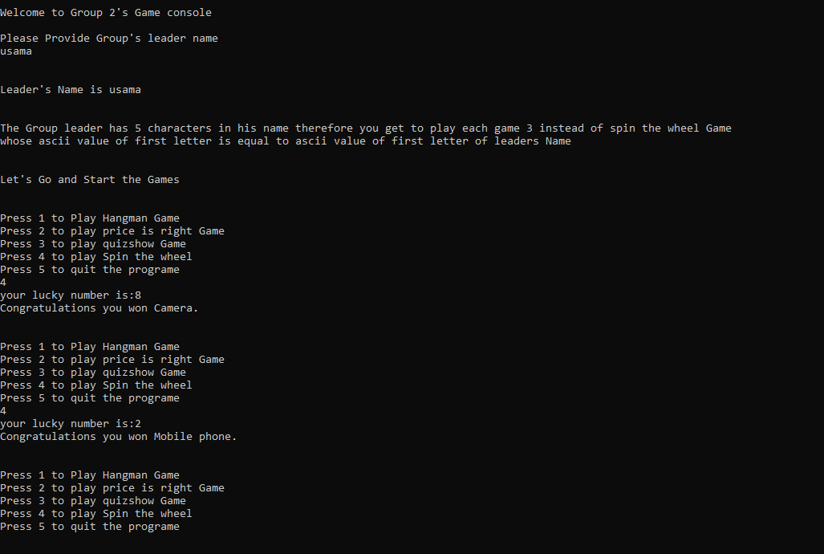cout <<"Program ended . Thank you for playing";}

**Output:**

